Khulna University Library
Lending card
Card not transferable
Card No. : | Academic Year
Name :
Hall : | Class
Roll No. : | Discipline :
Duration : 30th June 2021

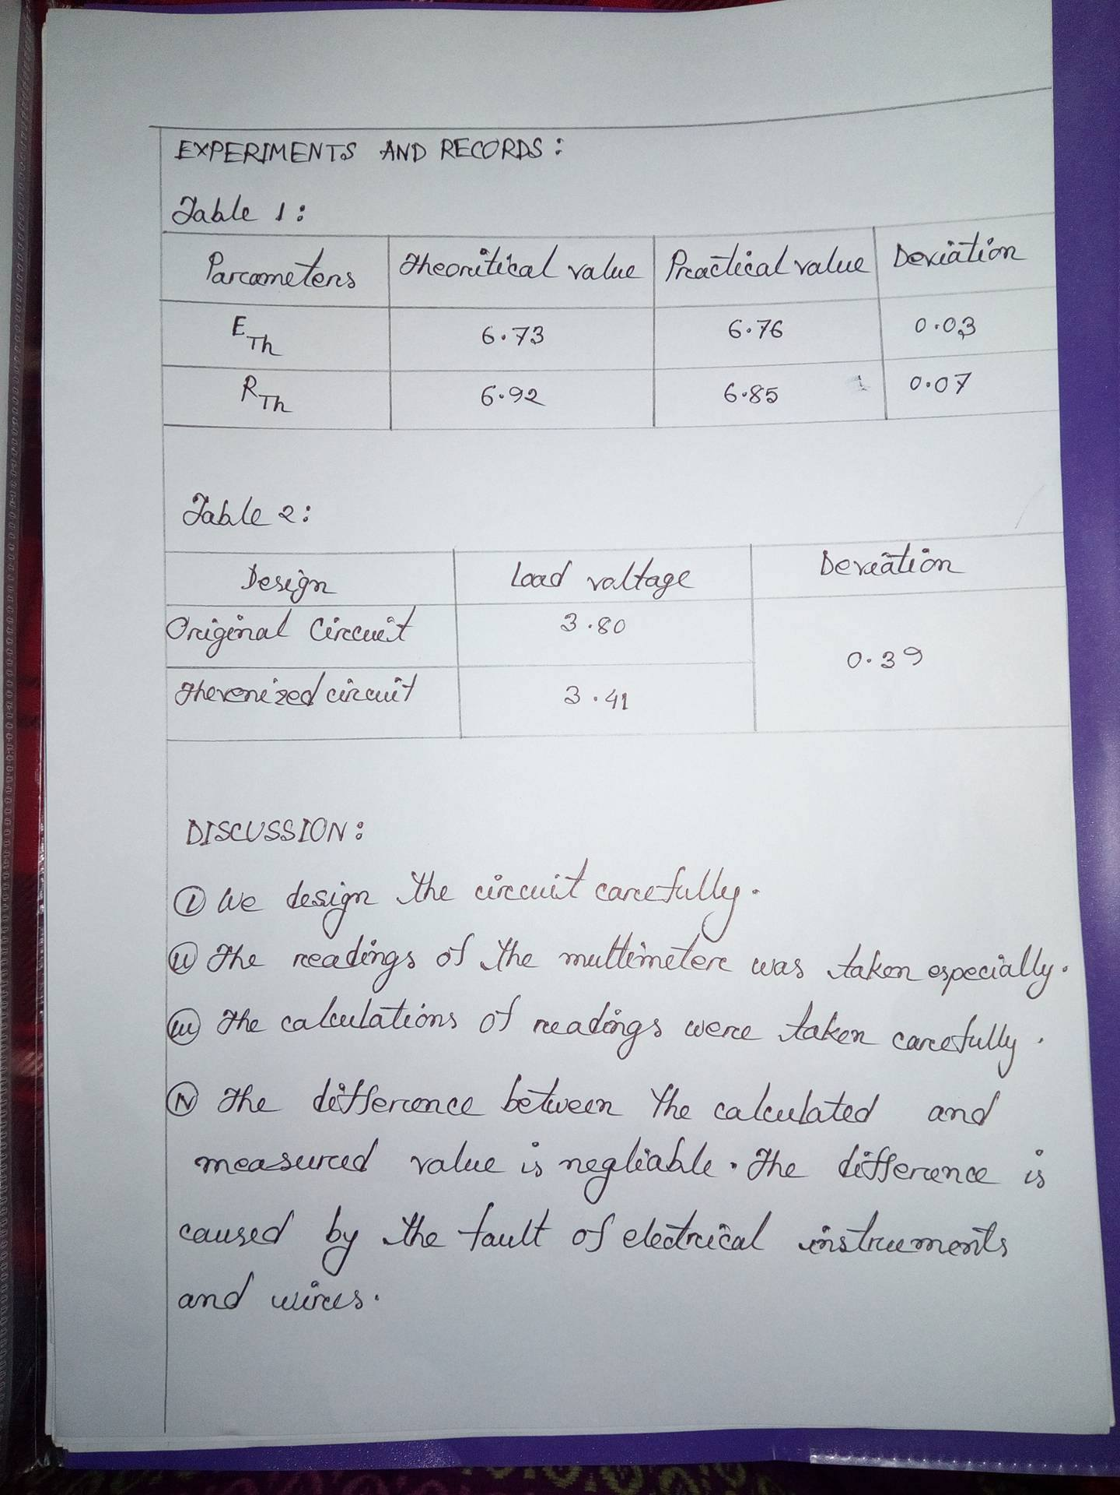
Liberarian

Borrower’s Signature

